SQL Queries:

#standardSQL

--1) Overall temperature over time

SELECT date,

  DATE(

    DIV(date,10000),

    DIV(MOD(date,10000),100),

        MOD(date,100)

  ) as formatted_date,

  AVG(cast(TAVG as float64)) as avg_temperature

FROM `i-multiplexer-406919.weather_data_historical.weather_data_historical_master`

where TAVG is not null

GROUP BY 1,2

ORDER BY formatted_date;

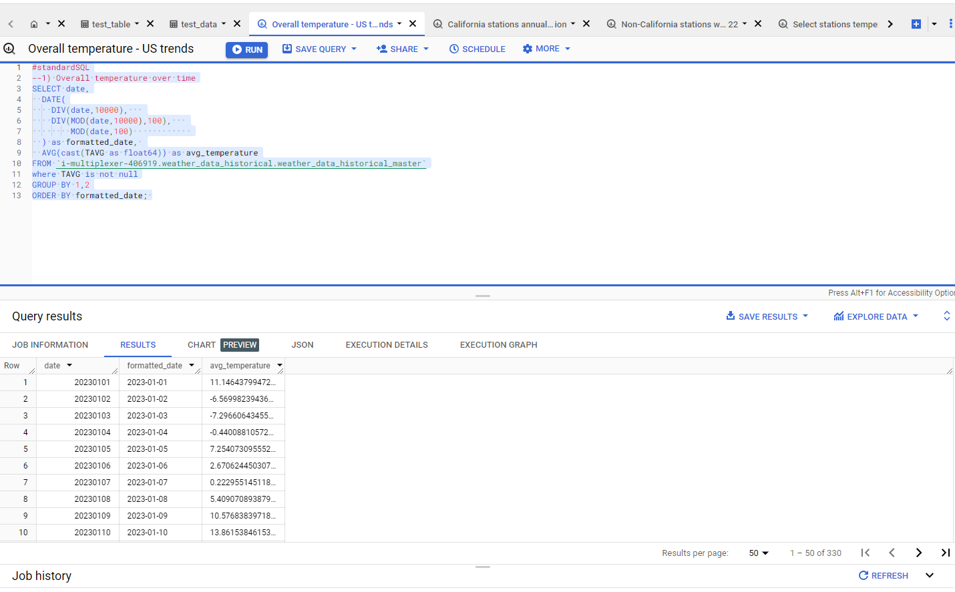

#standardSQL

--2) Total precipitation across each station in California across year

select extract(year from date_formatted) as year, station_name, SUM(total_precipitation) as total_precipitation from

  (SELECT   DATE(

    DIV(date,10000),

    DIV(MOD(date,10000),100),

        MOD(date,100)

  ) as  date_formatted, s.station_name, SUM(coalesce(PRCP,0)) as total_precipitation

  FROM `i-multiplexer-406919.weather_data_historical.weather_data_historical_master` w

  join `i-multiplexer-406919.weather_data_historical.weather_data_station_mapping_california` s

on upper(concat('GHCND:',trim(w.station_id))) = upper(trim(s.station_id))

  GROUP BY 1,2)

group by 1,2;

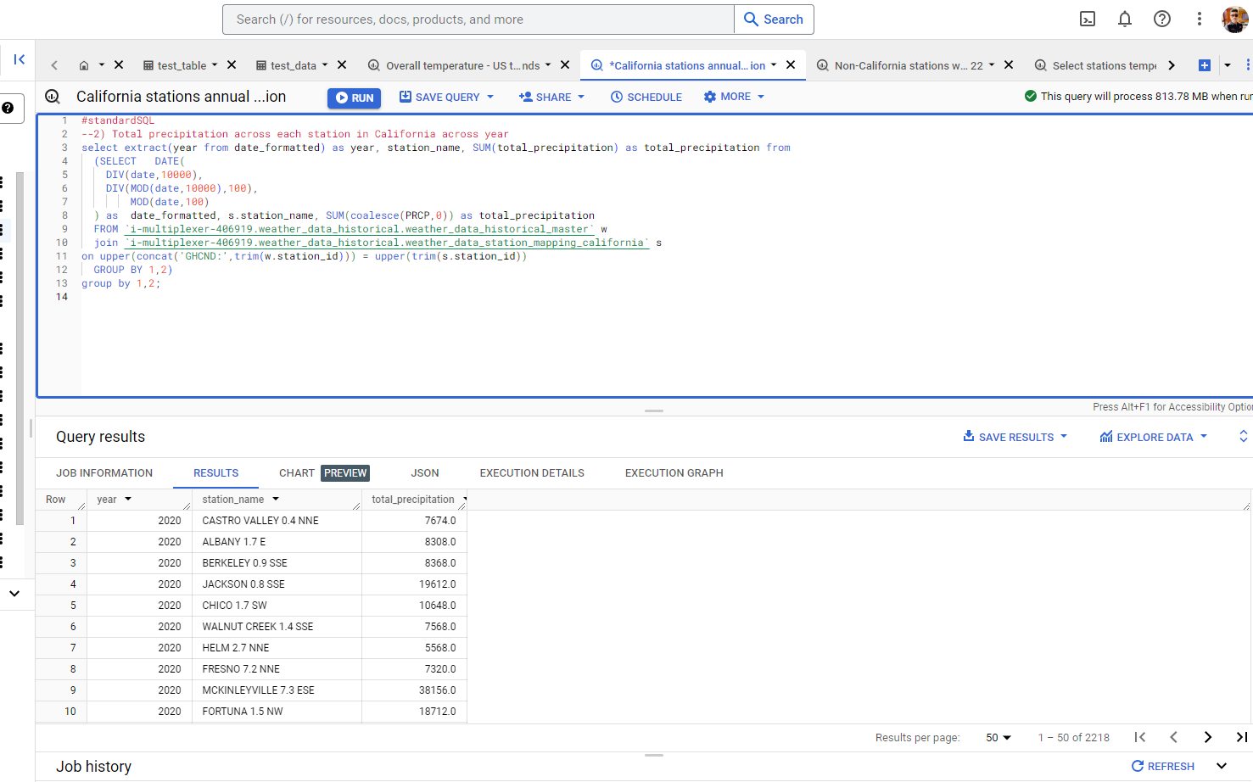

--3) Avg temperature of non California weather stations with reports of no snow in December for 2022

SELECT w.station_id, AVG(cast (TAVG as FLOAT64)) as avg_temperature

FROM `i-multiplexer-406919.weather_data_historical.weather_data_historical_master` w

  left join `i-multiplexer-406919.weather_data_historical.weather_data_station_mapping_california` s

on upper(concat('GHCND:',trim(w.station_id))) = upper(trim(s.station_id))

where (coalesce(SNOW,0) = 0 or SNOW is null)

and s.station_id is null

and DATE(

    DIV(date,10000),

    DIV(MOD(date,10000),100),

        MOD(date,100)

  ) between '2022-12-01' and '2022-12-31'

  and TAVG is not null

GROUP BY 1

order by 2 desc;

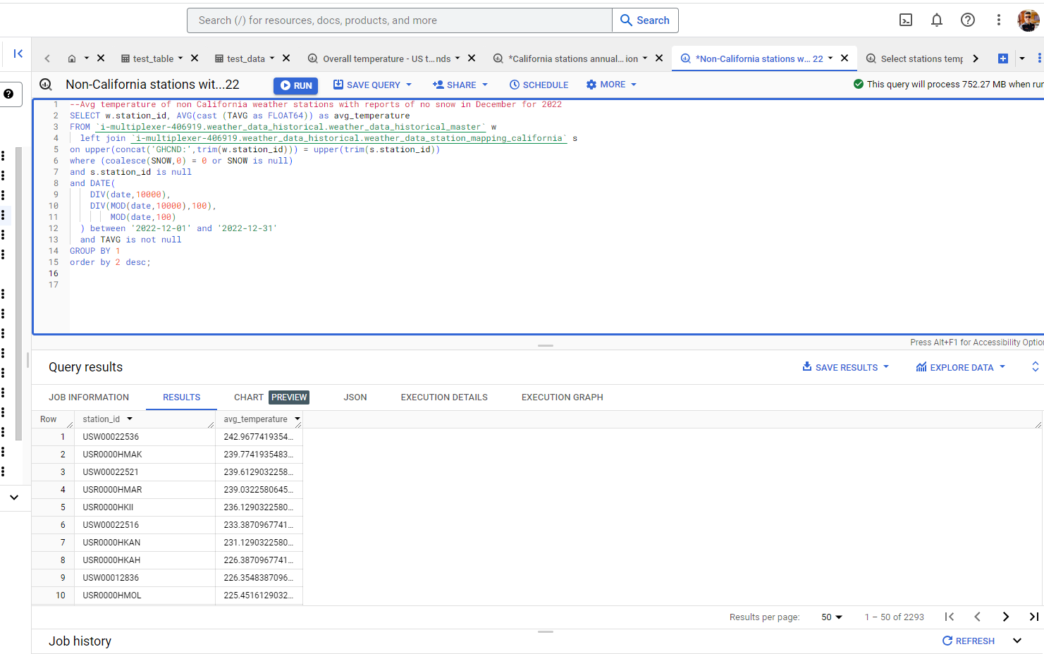

#standardSQL

--4) Total precipitation and avg temperature for select stations for the year 2022

select LEFT(station_id,5) AS state_code,

AVG(cast(TAVG as float64)) as avg_temperature,

SUM(coalesce(cast(PRCP as float64),0) ) as total_precipitation

FROM `i-multiplexer-406919.weather_data_historical.weather_data_historical_master`

where DATE(

    DIV(date,10000),

    DIV(MOD(date,10000),100),

        MOD(date,100)

  ) between '2022-01-01' and '2022-12-31'

  and TAVG is not null

GROUP BY 1;

